Step 1:

Unzip file AdventureWorks2008_Database.rar

Step 2:

Right click on Database and choose Attach...

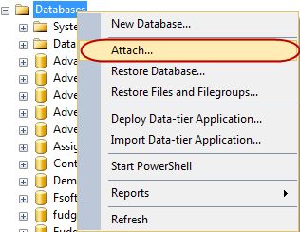

Step 3:

On Attach Databases diaglog, choose Add... and select database location and click OK

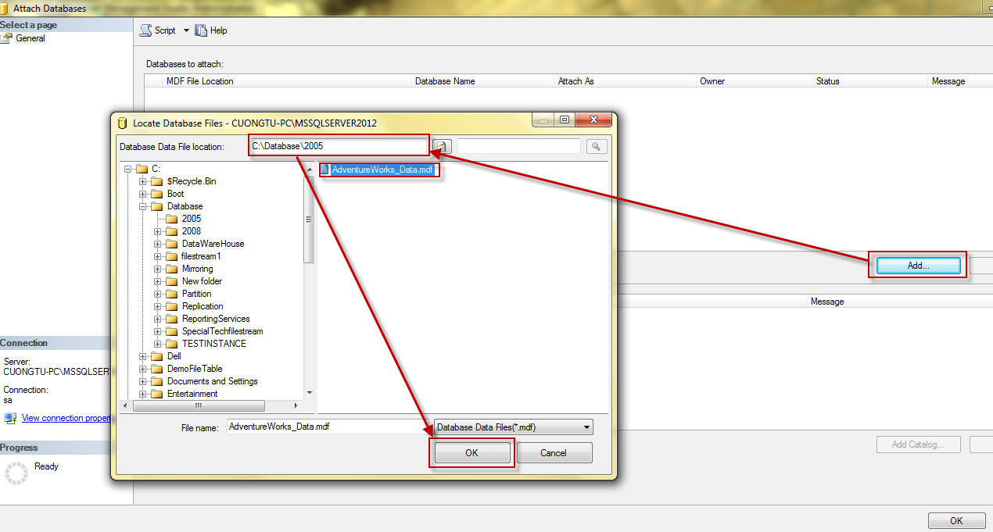

Done.